12. Credit for these combined materials and the links referred, to:
- Stephen Kerr and The Irish Inquiry – for the YouTube exposé video “The Falsk Fraud”.
- David Egan and Aindriu Holst at the Lay Advocacy Group with assistance from Teresa Clyne, BA, MSc for the documents, legal challenges and exhibits linked here below.
- Joe Doocey, Kevin Taylor, and Brendan and Melissa Kelly for various informations.
- Martin O’Toole for his own first-hand account of events and his courageous attempts to apply Common Law in his defence.
- Various confidential sources that provided clarity on much of the previously-unpublished detail herein.
- To Ken Donnelly & Diarmaid Ó Cadhla at Corruption Awareness Ireland, plus Rebel Telly and Garrie Beattie for their various insightful video reports.
- Plus all those who have attended the Court hearings or supported truth and justice in various ways throughout this historical event; a shameful and shocking travesty on the one side, and (alleged violence aside) a noble and courageous act of necessary defiance of – and disengagement with – endemic official lawlessness on the other.
But THAT (as Russell Brand would say) is just my own (not-so) humble opinion!
* * *
Online links (Ctrl + click to activate): Or, go to ‘Latest News’ page on the I-I website.
Advisory-Warning letter to Fintan Murphy from Anthony McGann, September 2018.
Lay Advocacy Group ‘Observations Letter’+ Grounds for a Mistrial + Exhibits. (proofs of fraud)
Corruption in the Courts: The Falsk Fraud - YouTube. (concise breakdown of documentary frauds)
Eviction at Falsk, Roscommon December 11th 2018. Violent assaults on McGanns & friends.
News report of the ‘vigilante’ response on December 16th 2018. Video report by Rebel Telly.
Lies and political provocations by Leo Varadkar in the Dail. Video report by Gary Beattie.
Integrity Ireland video interview with retired Garda Kevin Taylor after his spurious conviction.
The ‘Falsk Four’ trial video report by Joe Doocey. By Diarmaid at Corruption Awareness Ireland
Black Sheep Media interview with Kevin Taylor – post sentencing. An evasive Fintan Murphy.
* * *
Note: In an interesting ‘co-incidence’ one of the DPP Barristers in this case, Ms Jane McGowan was dispatched from Dublin to distant Clifden in Connemara on June 27th 2023 to tag-team with Judge James O’Donohue and other compromised ‘Officers of the Court’ to ensure that a contrived Circuit Court hearing (wherein pro-justice activist Stephen Manning was exposing widespread systemic corruption in the Courts) was shut down without further ado. Despite not being allowed to reference his own paperwork or call witnesses, Stephen won his appeal on the indisputable video evidence. Nevertheless, Stephen was subsequently jailed for three months on false and concocted charges leaving his special needs son vulnerable to the attentions of State ‘care services’. Meanwhile, Stephen’s legally-parked vehicle was mysteriously broken in-to; the insurance disc stolen; and the vehicle towed away ‘for no insurance and causing an obstruction.’ This caused considerable damage that cost hundreds of Euros in fines and recovery fees. Courts Service staff then lied about the circumstances of removal. C.S. Manager Pattie Mulkerrin, Courts Service CEO Angela Denning and Minister Helen McEntee are refusing to acknowledge or respond to our enquiries. Stephen is now facing further charges for those alleged traffic offences.
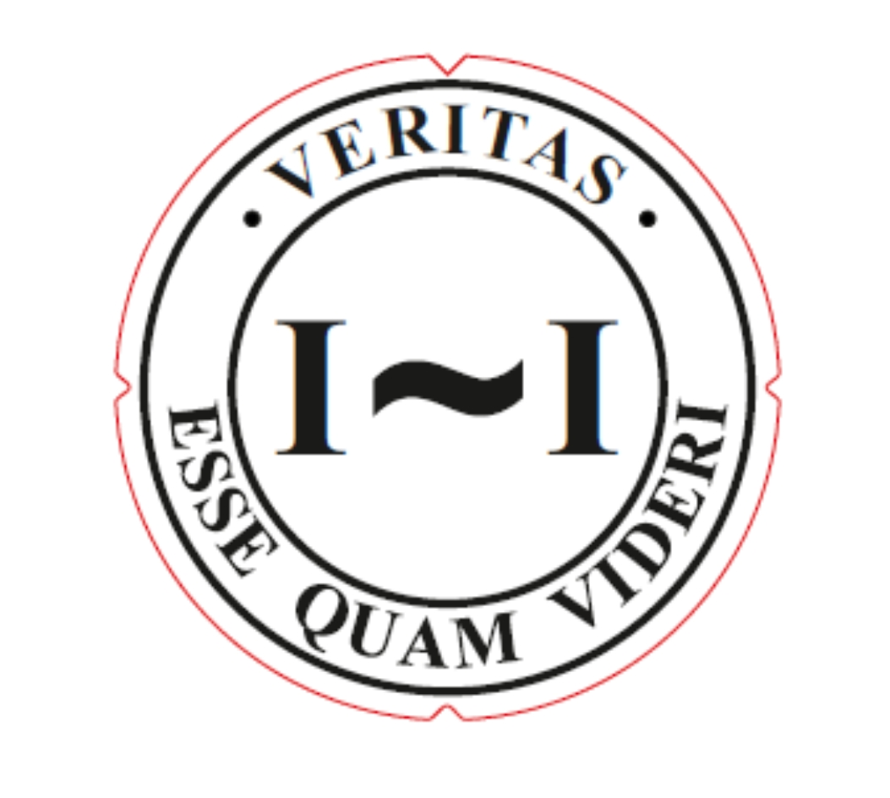
Document composed, edited and collated by the Integrity Ireland Association, 2023.
One by one – together – we CAN make a difference!

